Develop the inverse kinematics, and demonstrate how it could be used

We can use the inverse kinematics to calculate the position of the end effector, this is very useful for our robot. We will use the cartesian trajectory because we the end effector to stay steady when we approach and delivers a pallet.

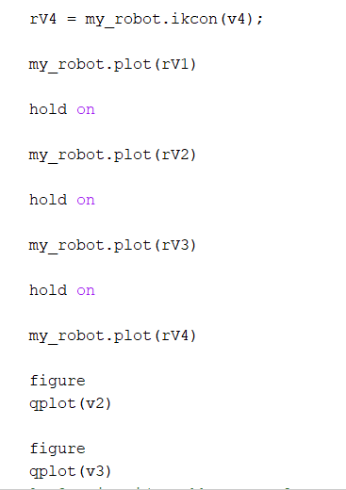

This gives us a good trajectory of the end effector to stay steady, and can perform good for our robot.